TASK: update data layer in 3T project replace collections by database
Handle exceptions properly

Database Connection:
Optimistic Concurrency:
Last & Win Concurrency:
Pessimistic Concurrency:

Architecture Type:
Connected Architecture: update, insert, delete with exclusive lock
Optimistic Concurrency:
Last & Win Concurrency:

Disconnected Architecture: (reading)
Pessimistic Concurrency:

For big transaction we have to do one by one by using locks.
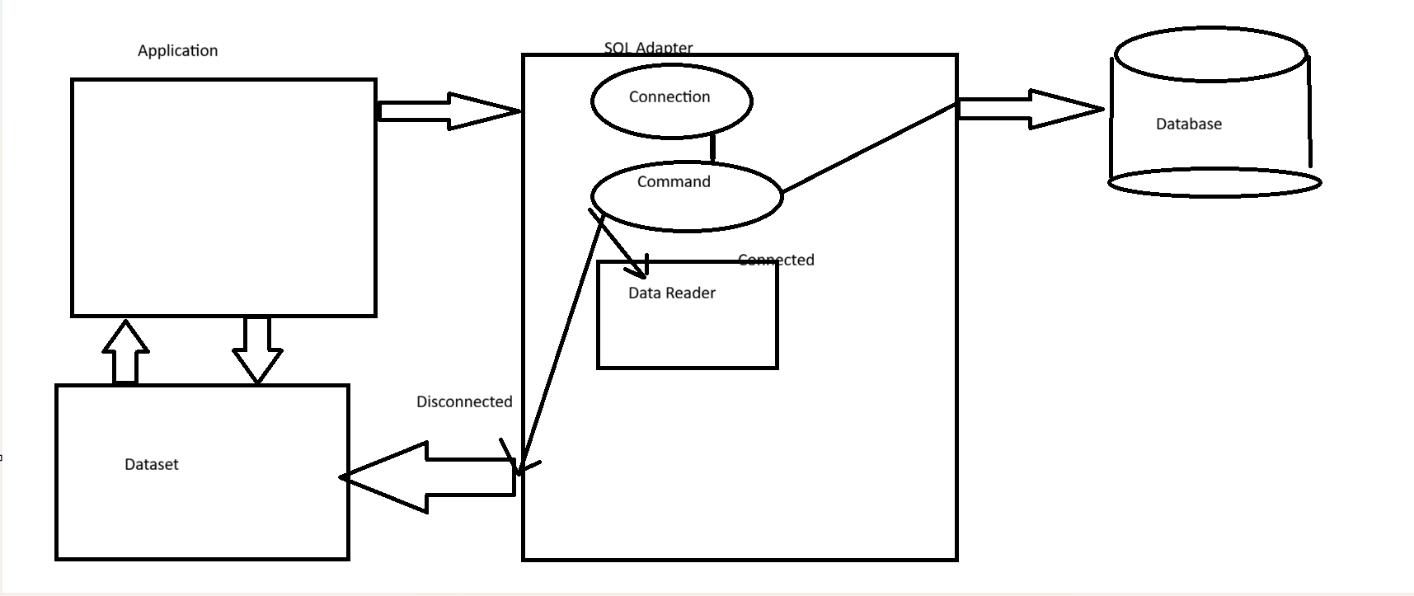

ADO.NET
ADO.NET is a data access technology developed by Microsoft as part of the .NET framework. It is used to connect applications (desktop, web, enterprise apps, APIs) with databases and other data sources.
In simple words:
ADO.NET acts like a bridge between your application and a database.
For example:
Your C# app → ADO.NET → Database → Returns data back to your app

Why ADO.NET was introduced?
Before ADO.NET, Microsoft had older technologies like:
- ODBC (Open Database Connectivity)
- DAO
- RDO
- Classic ADO
ADO.NET was designed to:
- Work efficiently with .NET applications
- Support disconnected architecture
- Improve performance
- Work easily with XML data
- Support multiple databases

Architecture of ADO.NET
Here’s the basic flow:
ADO.NET mainly has two parts:

1. .NET Data Provider
This handles direct communication with the database.
Main components:

(a) Connection
Used to open a connection with database.
Example classes:
- SqlConnection → for Microsoft SQL Server
- OleDbConnection
- OracleConnection
Example:
SqlConnection con = new SqlConnection(connectionString);
con.Open();
Purpose:
- Establish connection with database
- Authenticate user
- Maintain session

(b) Command
Used to execute SQL queries.
Example:
SELECT * FROM Students;
In C#:
SqlCommand cmd = new SqlCommand("SELECT * FROM Students", con);
Types of commands:
- SELECT
- INSERT
- UPDATE
- DELETE
- Stored Procedures

(c) DataReader
Reads data row by row.
Fast and memory efficient.
Example:
SqlDataReader dr = cmd.ExecuteReader();
Features:
- Forward-only
- Read-only
- Connected architecture
Use when:
Large amount of data needs to be read quickly.

(d) DataAdapter
Acts as bridge between database and DataSet.
Example:
SqlDataAdapter da = new SqlDataAdapter(cmd);
Purpose:
- Fetch data
- Fill DataSet
- Update database

2. DataSet
A DataSet is an in-memory copy of data.
Think of it like a temporary database inside your application.
Features:
- Stores multiple tables
- Stores relationships
- Can work offline
Example:
DataSet ds = new DataSet();
da.Fill(ds);

Connected vs Disconnected Architecture

1. Connected Architecture
Database connection remains open.
Uses:
- Connection
- Command
- DataReader
Flow:
App → Database → Read data → Close connection
Advantages:
- Fast
- Low memory usage
Disadvantages:
- Connection stays busy

2. Disconnected Architecture
Connection opens briefly, data is copied, then connection closes.
Uses:
- DataAdapter
- DataSet
Flow:
App → Database → Copy data → Connection closes
Advantages:
- Better scalability
- Multiple users supported
Disadvantages:
- More memory usage

ADO.NET Providers
Different providers exist for different databases:
Provider | Database
SqlClient | Microsoft SQL Server
OleDb | Multiple sources
Odbc | Generic databases
OracleClient | Oracle databases

Important Classes
Some important namespaces:
using System.Data;
using System.Data.SqlClient;
Common classes:
Class | Purpose
Connection | Connect database
Command | Execute queries
DataReader | Read data
DataAdapter | Transfer data
DataSet | Store data
DataTable | Single table

CRUD Operations in ADO.NET
CRUD means:

Create
INSERT INTO Students VALUES(...)

Read
SELECT * FROM Students

Update
UPDATE Students SET Name='Vaibhav'

Delete
DELETE FROM Students WHERE Id=1
These operations are usually executed using SqlCommand.

Example Workflow
Suppose a student management system:
- User enters details
- App uses ADO.NET
- Query is sent to database
- Database stores/retrieves data
- Result shown to user
Example use cases:
- Banking apps
- Student portals
- Hospital systems
- Inventory systems

Advantages of ADO.NET
✅ High performance
✅ Secure database communication
✅ Supports disconnected model
✅ Supports XML integration
✅ Scalable
✅ Works with multiple databases

Disadvantages
❌ More code compared to ORM tools
❌ Manual query writing
❌ Can become complex in large projects

ADO.NET vs ORM
ADO.NET vs ORM tools like Entity Framework:
ADO.NET | ORM
More control | Less code
Faster in many cases | Easier development
Manual SQL | Auto-generated queries

Interview Questions

What is ADO.NET?
ADO.NET is a .NET data access technology used to connect applications with databases.

Difference between DataReader and DataSet?
- DataReader → Connected, fast, read-only
- DataSet → Disconnected, editable, stores multiple tables

What is DataAdapter?
It acts as bridge between database and DataSet.

TASK: update data layer in 3T project replace collections by database

